Assignment : 1 – With Using Terraform create VPC, SUBNET, Sg and EC2 instance inside ec2 created simple index.html file and put in the httpd location for deployment. Also install httpd using usedata concept and httpd started.

Terraform snapshot where terraform apply ssuccessfully.
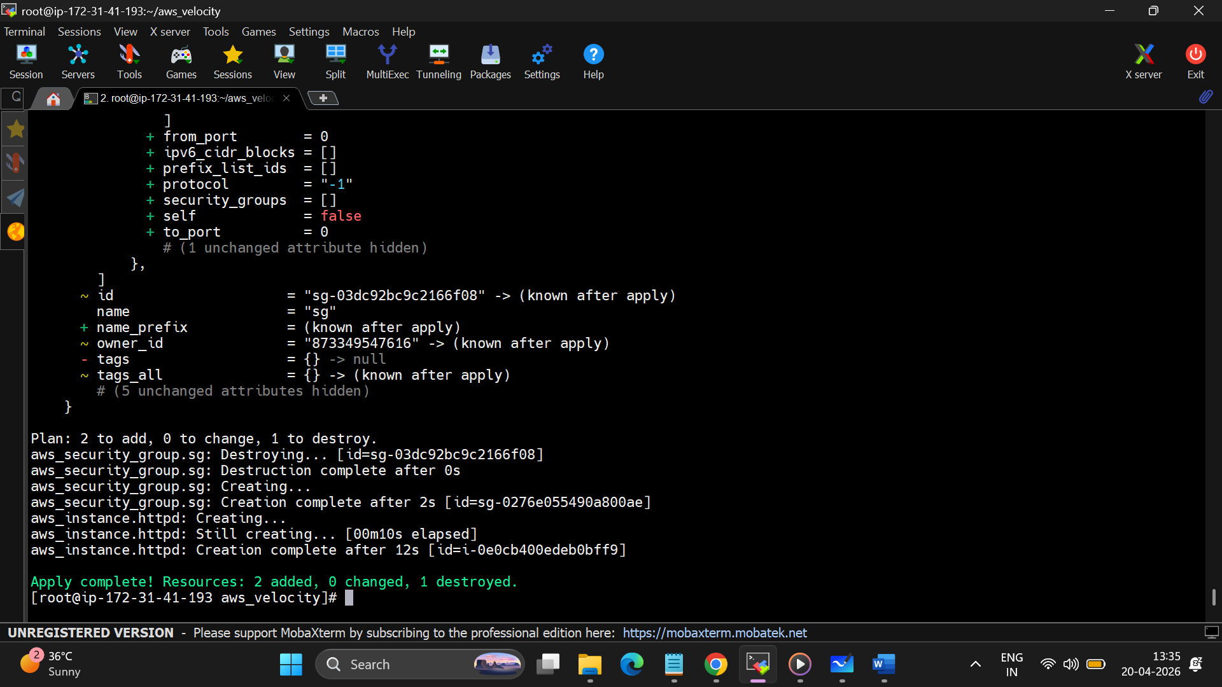

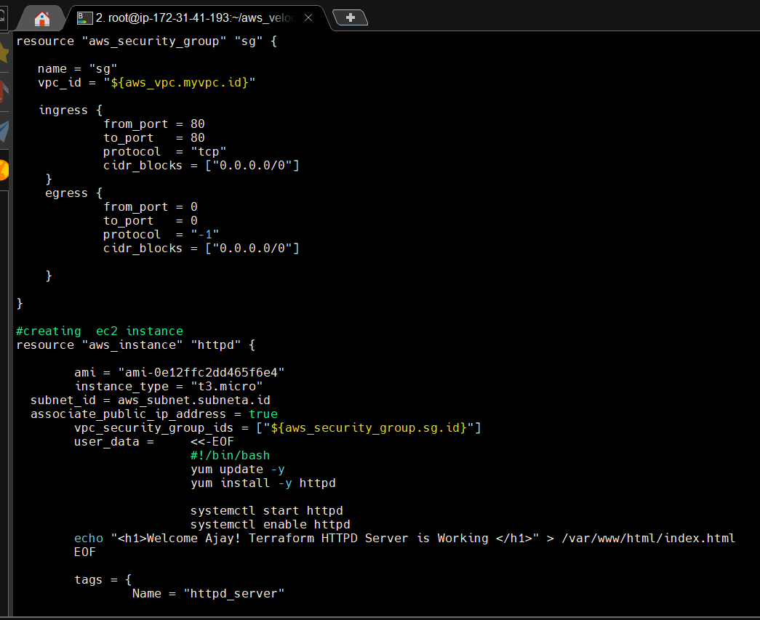
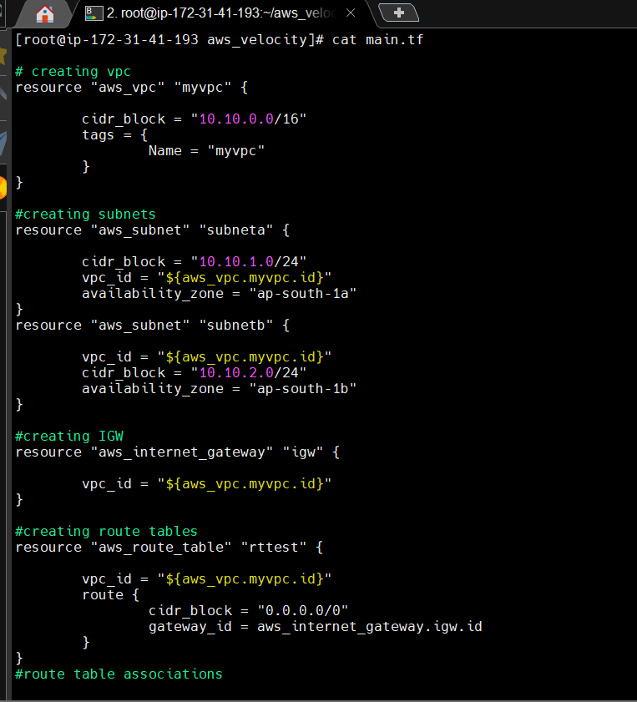
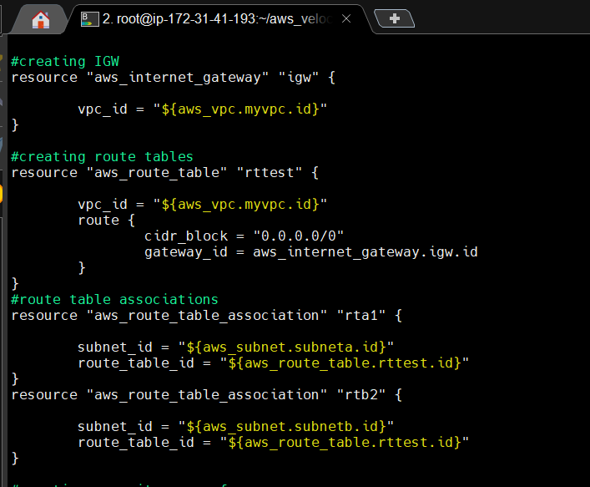

2. ec2 instace of httpd-server created by terraform script
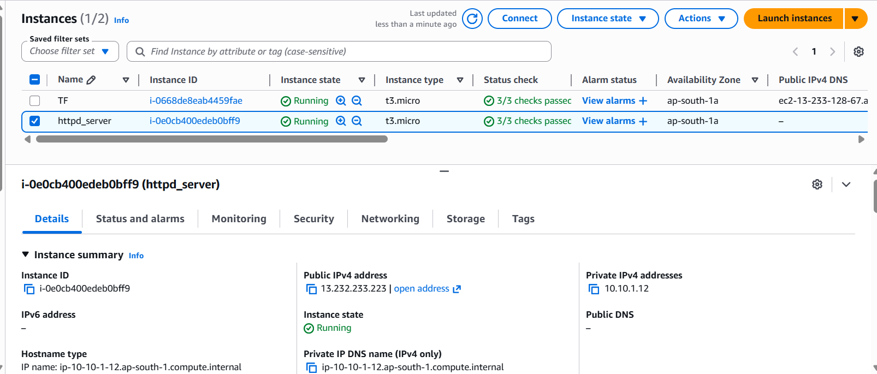
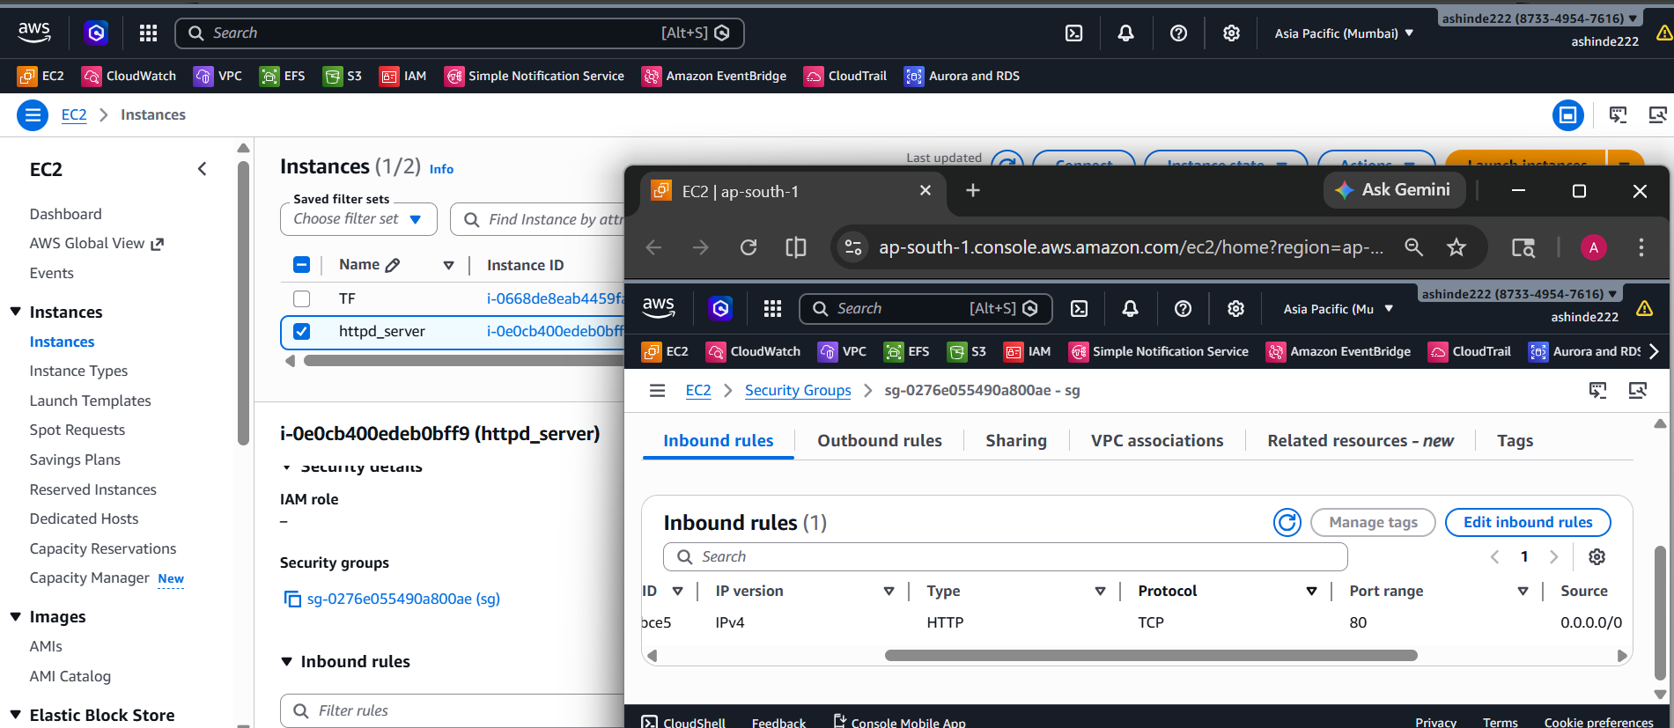
3. vpc and subnet with route tables and association of IGW
